**SRM Institute of Science and Technology**

**College of Engineering and Technology**

**DEPARTMENT OF ECE**

SRM Nagar, Kattankulathur – 603203, Chengalpattu District, Tamilnadu

**Academic Year: 2021-2022 (EVEN)**

**Batch 1**

**Test: CLAT-3** **Date: 27/06/22**

**Course Code & Title:** 18ECC202J / Linear Integrated Circuits **Duration:** 2 Periods

**Year & Sem:** II year / IV Sem **Max. Marks:** 50

**Course Articulation Matrix:**

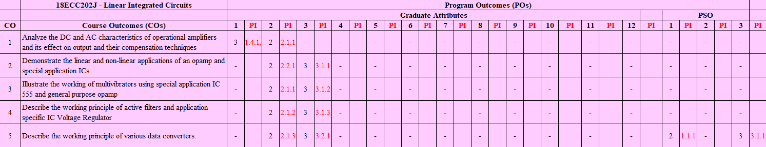

|  |  |  |  |  |  |  |
| --- | --- | --- | --- | --- | --- | --- |
| **Part - A**  **(10 x 1 = 10 Marks)**  **Instructions: Answer ALL** | | | | | | |
| **Q. No** | **Question** | **Marks** | **BL** | **CO** | **PO** | **PI** |
| **1** | d. Filter | 1 | 1 | 4 | 2 | 2.1.2 |
| **2** | b. Q > 10 | 1 | 1 | 4 | 2 | 2.1.2 |
| **3** | d. HPF and LPF | 1 | 1 | 4 | 2 | 2.1.2 |
| **4** | a. |Vin| ≥ |Vo|+2v | 1 | 2 | 4 | 2 | 2.1.2 |
| **5** | d.   90 | 1 | 1 | 4 | 2 | 2.1.2 |
| **6** | b. Successive approximation | 1 | 1 | 5 | 2 | 2.1.3 |
| **7** | b. 666.67mV | 1 | 2 | 5 | 3 | 3.2.1 |
| **8** | a. Flash | 1 | 1 | 5 | 2 | 2.1.3 |
| **9** | c. an increase in digital input | 1 | 1 | 5 | 2 | 2.1.3 |
| **10** | a. 3.78 V | 1 | 2 | 5 | 3 | 3.2.1 |
| **Part – B**  **( 4 x 10 = 40 Marks)** | | | | | | |
| **SECTION B1**  **Instructions: Answer ANY 2 Questions** | | | | | |  |
| 11 |  | 10 | 3 | 4 | 3 | 3.2.1 |
| 12 |  | 10 | 3 | 4 | 2 | 2.1.2 |
| 13 | **4M** | 10 | 2 | 4 | 2 | 2.1.2 |

|  |  |  |  |  |  |  |
| --- | --- | --- | --- | --- | --- | --- |
| **SECTION B2**  **Instructions: Answer ANY 2 Questions** | | | | | | |
| 14 | With a neat sketch, explain the operation of weighted resistor DAC      Drawbacks - | 10 | 3 | 5 | 2 | 2.1.3 |
| 15 | Operation - | 10 | 2 | 5 | 2 | 2.1.3 |
| 16a |  | 6 | 4 | 5 | 3 | 3.1.2 |
| 16b |  | 4 | 4 | 5 | 3 | 3.1.2 |